**“NATURAL LANGUAGE PROCESSING”**

**PRACTICAL MANUAL**

Submitted in partial fulfillment of the

requirements for award of the Master degree of

**MASTERS OF SCIENCE** **(INFORMATION TECHNOLOGY)**

**submitted by**

**BHAVIKA MANOHAR MULCHANDANI**

**SEAT NO - 4136294**

**Under the esteemed guidance of**

**ASST. PROF. ARCHANA NAIR**



**DEPARTMENT OF SCIENCE (INFORMATION TECHNOLOGY)**

**S.S.T. COLLEGE OF ARTS & COMMERCE**

***(Affiliated to University of Mumbai)* ULHASNAGAR-421004**

**MAHARASHTRA 2022-2023**

**Index**

|  |  |  |  |  |
| --- | --- | --- | --- | --- |
| **Sr.No** | **Topic** | **Page no.** | **Date** | **Remark** |
| 1 | 1. Install NLTK 2. Convert the given text to speech. 3. Convert audio file Speech to Text. | 3-5 |  |  |
| 2 | 1. Study of various Corpus – Brown, Inaugural, Reuters, udhr with various methods like filelds, raw, words, sents, categories. 2. Create and use your own corpora (plaintext, categorical) 3. Study Conditional frequency distributions 4. Study of tagged corpora with methods like tagged_sents, tagged_words. 5. Write a program to find the most frequent noun tags. 6. Map Words to Properties Using Python Dictionaries 7. Study DefaultTagger, Regular expression tagger, UnigramTagger 8. Find different words from a given plain text without any space by comparing this text with a given corpus of words. Also find the score of words. | 6-10 |  |  |
| 3 | 1. Study of Wordnet Dictionary with methods as synsets, definitions, examples, antonyms 2. Study lemmas, hyponyms, hypernyms. 3. Write a program using python to find synonym and antonym of word "active" using Wordnet. 4. Compare two nouns 5. Handling stopword:  Using nltk Adding or Removing Stop Words in NLTK's Default Stop Word List  * 1. Using Gensim Adding and Removing Stop Words in Default Gensim Stop Words List  Using Spacy Adding and Removing Stop Words in Default Spacy Stop Words List | 11-25 |  |  |
| 4 | **Text Tokenization**   * 1. Tokenization using Python’s split() function   2. Tokenization using Regular Expressions (RegEx)   3. Tokenization using NLTK   4. Tokenization using the spaCy library   5. Tokenization using Keras   6. Tokenization using Gensim | 26-34 |  |  |
| **Sr.No** | **Topic** | **Page no.** | **Date** | **Remark** |
| 5 | **Import NLP Libraries for Indian Languages and perform:**   1. word tokenization in Hindi 2. Generate similar sentences from a given Hindi text input 3. Identify the Indian language of a text | 40-42 |  |  |
| 6 | Illustrate part of speech tagging.  * 1. Part of speech Tagging and chunking of user defined text.  Named Entity recognition of user defined text.  * 1. Named Entity recognition with diagram using NLTK corpus – treebank | 43-46 |  |  |
| 7 | **Finite state automata**   1. Define grammar using nltk. Analyze a sentence using the same. 2. Accept the input string with Regular expression of Finite Automaton: 101+. 3. Accept the input string with Regular expression of FA: (a+b)*bba.  Implementation of Deductive Chart Parsing using context free grammar and a given sentence. | 47-50 |  |  |
| 8 | Study PorterStemmer, LancasterStemmer, RegexpStemmer, SnowballStemmer Study WordNetLemmatizer | 51-52 |  |  |
| 9 | Implement Naive Bayes classifier | 53-55 |  |  |
| 10 | a**. Speech Tagging:** i. Speech tagging using spacyii. Speech tagging using nktl b**. Statistical parsing:** i. Usage of Give and Gave in the Penn Treebank sampleii. probabilistic parser **c. Malt parsing:**  Parse a sentence and draw a tree using malt parsing. | 56-61 |  |  |

# Practical No. 1

1. **Install NLTK**

**Python 3.9.2 Installation on Windows**

Step 1) **Go to link** https:/[/www.p](http://www.python.org/downloads/)y[thon.org/downloads/,](http://www.python.org/downloads/) **and select the latest version for windows.**

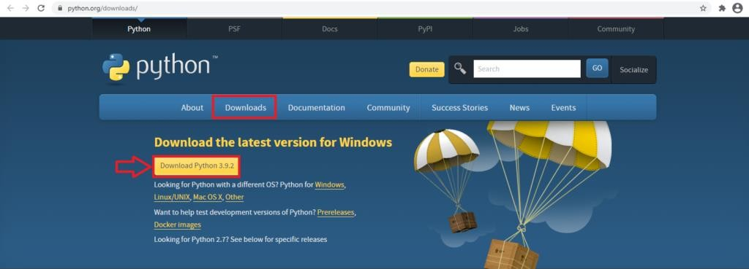

**Note**: If you don't want to download the latest version, you can visit the download tab and see all releases.

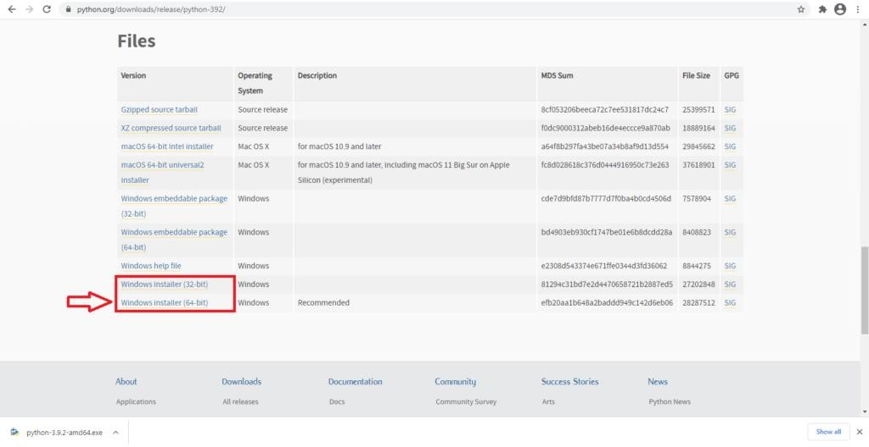

**Step 2)** Click on the Windows installer (64 bit)

**Step 3)** Select Customize Installation



**Step 4)** Click NEXT

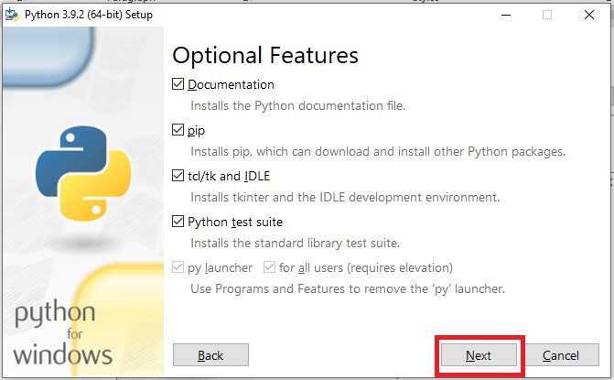

**Step 5)** In next screen

* 1. Select the advanced options
  2. Give a Custom install location. Keep the default folder as c:\Program files\Python39
  3. Click Install

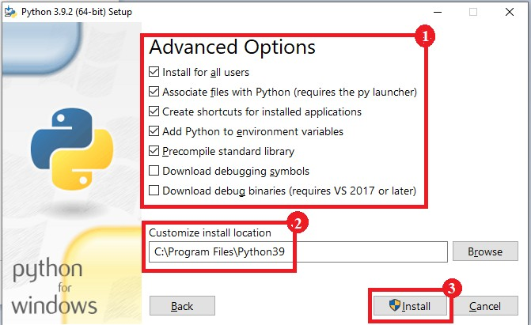

**Step 6)** Click Close button once install is done.

**Step 7) open** command prompt window and run the following commands: C:\Users\Beena Kapadia>pip install --upgrade pip

C:\Users\Beena Kapadia> pip install --user -U nltk C:\Users\Beena Kapadia> >pip install --user -U numpy C:\Users\Beena Kapadia>python

>>> import nltk

>>>

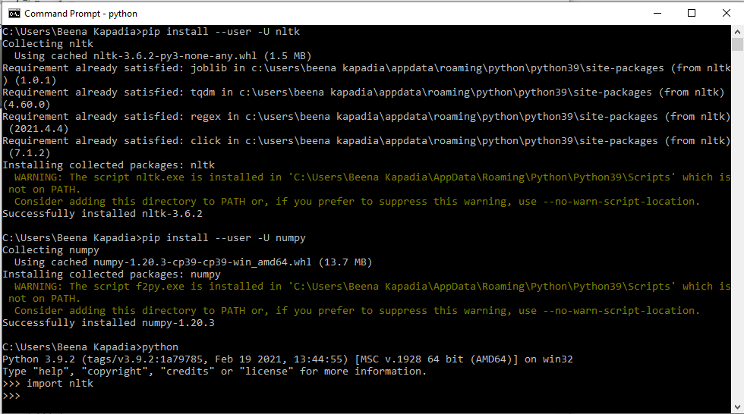

# Convert the given text to speech. Source code:

# text to speech # pip install gtts

# pip install playsound

from playsound import playsound

# import required for text to speech conversion from gtts import gTTS

mytext = "Welcome to Natural Language programming" language = "en"

myobj = gTTS(text=mytext, lang=language, slow=False) myobj.save("myfile.mp3")

playsound("myfile.mp3")

# Output:

welcomeNLP.mp3 audio file is getting created and it plays the file with playsound() method, while running the program.

# Convert audio file Speech to Text. Source code:

Note: required to store the input file "male.wav" in the current folder before running the program.

#pip3 install SpeechRecognition pydub

import speech_recognition as sr filename = "male.wav"

# initialize the recognizer r = sr.Recognizer()

# open the file

with sr.AudioFile(filename) as source:

# listen for the data (load audio to memory) audio_data = r.record(source)

# recognize (convert from speech to text) text = r.recognize_google(audio_data) print(text)

Input:

male.wav (any wav file)

# Output:

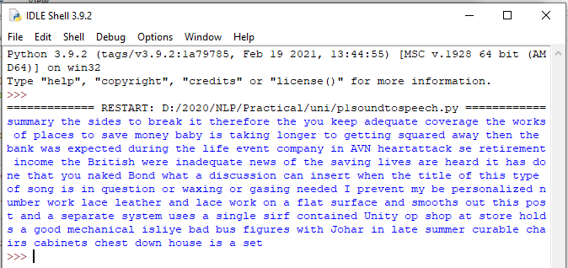

**Practical No. 2**

# Study of various Corpus – Brown, Inaugural, Reuters, udhr with various methods like filelds, raw, words, sents, categories.

1. **Create and use your own corpora (plaintext, categorical)**

# Study Conditional frequency distributions

1. **Study of tagged corpora with methods like tagged_sents, tagged_words.**

# Write a program to find the most frequent noun tags.

1. **Map Words to Properties Using Python Dictionaries**

# Study DefaultTagger, Regular expression tagger, UnigramTagger

1. **Find different words from a given plain text without any space by comparing this text with a given corpus of words. Also find the score of words.**

# Study of various Corpus – Brown, Inaugural, Reuters, udhr with various methods like fields, raw, words, sents, categories,

**source code:**

'''NLTK includes a small selection of texts from the Project brown electronic text archive, which contains some 25,000 free electronic books, hosted at [http://www.brown.org/.](http://www.brown.org/) We begin by getting the Python interpreter to load the NLTK package, then ask to see nltk.corpus.brown.fileids(), the file identifiers in this corpus:'''

import nltk

from nltk.corpus import brown

print ('File ids of brown corpus\n',brown.fileids())

'''Let’s pick out the first of these texts — Emma by Jane Austen — and give it a short name, emma, then find out how many words it contains:'''

ca01 = brown.words('ca01')

# display first few words

print('\nca01 has following words:\n',ca01)

# total number of words in ca01 print('\nca01 has',len(ca01),'words')

#categories or files

print ('\n\nCategories or file in brown corpus:\n') print (brown.categories())

'''display other information about each text, by looping over all the values of fileid corresponding to the brown file identifiers listed earlier and then computing statistics for each text.'''

print ('\n\nStatistics for each text:\n') print

('AvgWordLen\tAvgSentenceLen\tno.ofTimesEachWordAppearsOnAvg\t\tFileName') for fileid in brown.fileids():

num_chars = len(brown.raw(fileid)) num_words = len(brown.words(fileid)) num_sents = len(brown.sents(fileid))

num_vocab = len(set([w.lower() for w in brown.words(fileid)]))

print (int(num_chars/num_words),'\t\t\t', int(num_words/num_sents),'\t\t\t', int(num_words/num_vocab),'\t\t\t', fileid)

# output:

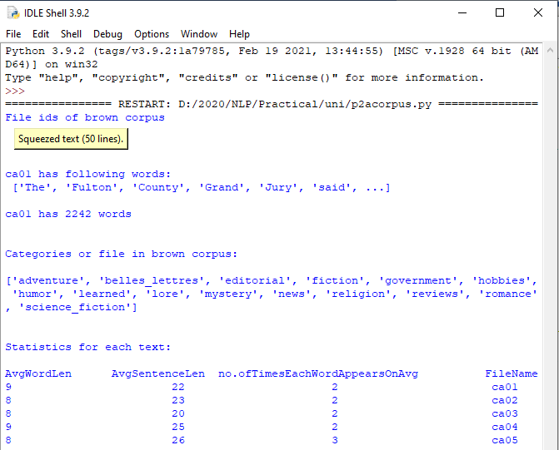

1. **Create and use your own corpora (plaintext, categorical) source code:**

'''NLTK includes a small selection of texts from the Project filelist electronic text archive, which contains some 25,000 free electronic books, hosted at [http://www.filelist.org/.](http://www.filelist.org/) We begin by getting the Python interpreter to load the NLTK package, then ask to see nltk.corpus.filelist.fileids(), the file identifiers in this corpus:'''

import nltk

from nltk.corpus import PlaintextCorpusReader

corpus_root = 'D:/2020/NLP/Practical/uni'

filelist = PlaintextCorpusReader(corpus_root, '.*') print ('\n File list: \n')

print (filelist.fileids()) print (filelist.root)

'''display other information about each text, by looping over all the values of fileid corresponding to the filelist file identifiers listed earlier and then computing statistics for each text.'''

print ('\n\nStatistics for each text:\n') print

('AvgWordLen\tAvgSentenceLen\tno.ofTimesEachWordAppearsOnAvg\tFileName') for fileid in filelist.fileids():

num_chars = len(filelist.raw(fileid)) num_words = len(filelist.words(fileid)) num_sents = len(filelist.sents(fileid))

num_vocab = len(set([w.lower() for w in filelist.words(fileid)]))

print (int(num_chars/num_words),'\t\t\t', int(num_words/num_sents),'\t\t\t', int(num_words/num_vocab),'\t\t', fileid)

# output:

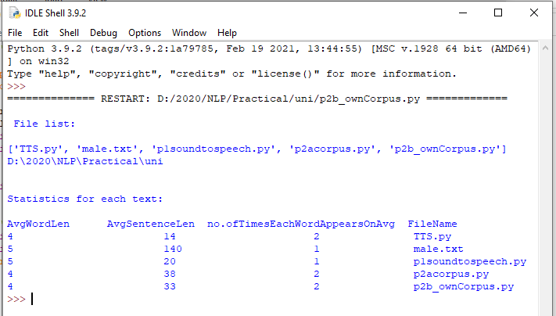

1. **Study Conditional frequency distributions source code:**

#process a sequence of pairs

text = ['The', 'Fulton', 'County', 'Grand', 'Jury', 'said', ...]

pairs = [('news', 'The'), ('news', 'Fulton'), ('news', 'County'), ...] import nltk

from nltk.corpus import brown fd = nltk.ConditionalFreqDist(

(genre, word)

for genre in brown.categories()

for word in brown.words(categories=genre))

genre_word = [(genre, word)

for genre in ['news', 'romance']

for word in brown.words(categories=genre)] print(len(genre_word))

print(genre_word[:4]) print(genre_word[-4:])

cfd = nltk.ConditionalFreqDist(genre_word) print(cfd)

print(cfd.conditions())

print(cfd['news']) print(cfd['romance']) print(list(cfd['romance']))

from nltk.corpus import inaugural cfd = nltk.ConditionalFreqDist(

(target, fileid[:4])

for fileid in inaugural.fileids() for w in inaugural.words(fileid) for target in ['america', 'citizen'] if w.lower().startswith(target))

from nltk.corpus import udhr

languages = ['Chickasaw', 'English', 'German_Deutsch', 'Greenlandic_Inuktikut', 'Hungarian_Magyar', 'Ibibio_Efik']

cfd = nltk.ConditionalFreqDist( (lang, len(word))

for lang in languages

for word in udhr.words(lang + '-Latin1'))

cfd.tabulate(conditions=['English', 'German_Deutsch'], samples=range(10), cumulative=True)

# output:

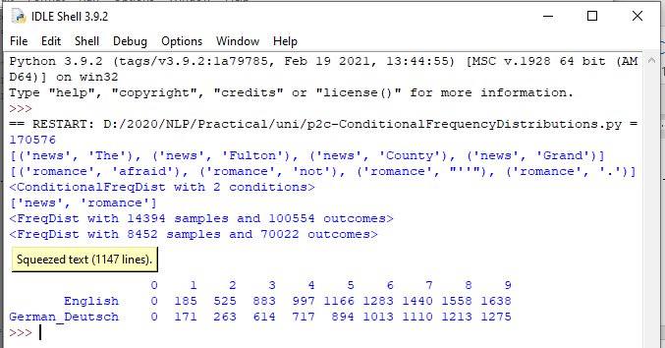

1. **Study of tagged corpora with methods like tagged_sents, tagged_words.**

# Source code:

import nltk

from nltk import tokenize nltk.download('punkt') nltk.download('words')

para = "Hello! My name is Beena Kapadia. Today you'll be learning NLTK." sents = tokenize.sent_tokenize(para)

print("\nsentence tokenization\n===================\n",sents)

# word tokenization

print("\nword tokenization\n===================\n") for index in range(len(sents)):

words = tokenize.word_tokenize(sents[index]) print(words)

# output:

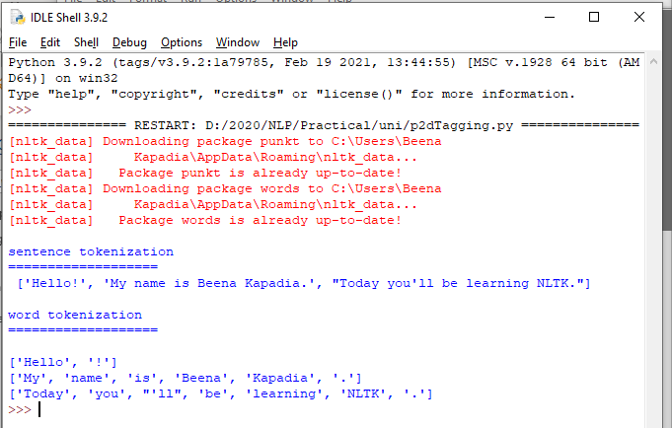

1. **Write a program to find the most frequent noun tags. Code:**

import nltk

from collections import defaultdict

text = nltk.word_tokenize("Nick likes to play football. Nick does not like to play cricket.")

tagged = nltk.pos_tag(text) print(tagged)

# checking if it is a noun or not addNounWords = []

count=0

for words in tagged:

val = tagged[count][1]

if(val == 'NN' or val == 'NNS' or val == 'NNPS' or val == 'NNP'): addNounWords.append(tagged[count][0])

count+=1

print (addNounWords) temp = defaultdict(int)

# memoizing count

for sub in addNounWords: for wrd in sub.split(): temp[wrd] += 1

# getting max frequency

res = max(temp, key=temp.get)

# printing result

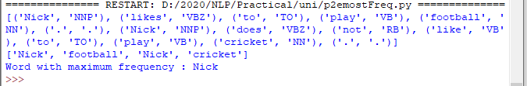print("Word with maximum frequency : " + str(res)) output:

# Map Words to Properties Using Python Dictionaries code:

#creating and printing a dictionay by mapping word with its properties thisdict = {

"brand": "Ford",

"model": "Mustang", "year": 1964

}

print(thisdict) print(thisdict["brand"]) print(len(thisdict)) print(type(thisdict))

# output:

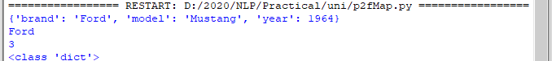

1. **Study i) DefaultTagger, ii) Regular expression tagger, iii) UnigramTagger**

# DefaultTagger code:

import nltk

from nltk.tag import DefaultTagger exptagger = DefaultTagger('NN') from nltk.corpus import treebank

testsentences = treebank.tagged_sents() [1000:] print(exptagger.evaluate (testsentences))

#Tagging a list of sentences import nltk

from nltk.tag import DefaultTagger exptagger = DefaultTagger('NN')

print(exptagger.tag_sents([['Hi', ','], ['How', 'are', 'you', '?']]))

# output

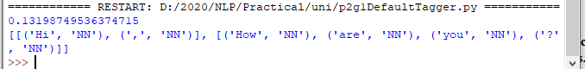

1. **Regular expression tagger, code:**

from nltk.corpus import brown from nltk.tag import RegexpTagger

test_sent = brown.sents(categories='news')[0] regexp_tagger = RegexpTagger(

[(r'^-?[0-9]+(.[0-9]+)?$', 'CD'), # cardinal numbers (r'(The|the|A|a|An|an)$', 'AT'), # articles (r'.*able$', 'JJ'), # adjectives

(r'.*ness$', 'NN'), # nouns formed from adjectives (r'.*ly$', 'RB'), # adverbs

(r'.*s$', 'NNS'), # plural nouns

(r'.*ing$', 'VBG'), # gerunds

(r'.*ed$', 'VBD'), # past tense verbs (r'.*', 'NN') # nouns (default)

])

print(regexp_tagger) print(regexp_tagger.tag(test_sent)) **output:**

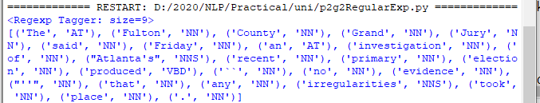

# UnigramTagger code:

# Loading Libraries

from nltk.tag import UnigramTagger from nltk.corpus import treebank

# Training using first 10 tagged sentences of the treebank corpus as data. # Using data

train_sents = treebank.tagged_sents()[:10]

# Initializing

tagger = UnigramTagger(train_sents)

# Lets see the first sentence

# (of the treebank corpus) as list print(treebank.sents()[0]) print('\n',tagger.tag(treebank.sents()[0]))

#Finding the tagged results after training. tagger.tag(treebank.sents()[0])

#Overriding the context model

tagger = UnigramTagger(model ={'Pierre': 'NN'}) print('\n',tagger.tag(treebank.sents()[0]))

# output:

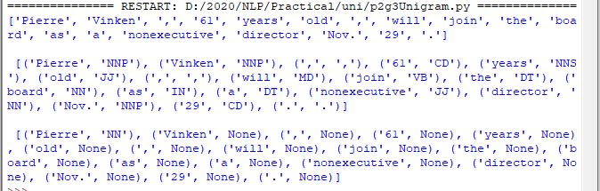

1. **Find different words from a given plain text without any space by comparing this text with a given corpus of words. Also find the score of words.**

# Question:

Initialize the hash tag test data or URL test data and convert to plain text without any space.. Read a text file of different words and compare the plain text data with the words exist in that text file and find out different words available in that plain text. Also find out how many words could be found. (for example, text = "#whatismyname" or text = [www.whatismyname.com.](http://www.whatismyname.com/) Convert that to plain text without space as: whatismyname and read text file as words.txt. Now compare plain text with words given in a file and find the words form the plain text and the count of words which could be found)

# Source code:

from future import with_statement #with statement for reading file import re # Regular expression

words = [] # corpus file words testword = [] # test words

ans = [] # words matches with corpus

print("MENU")

print(" ")

print(" 1 . Hash tag segmentation ") print(" 2 . URL segmentation ")

print("enter the input choice for performing word segmentation") choice = int(input())

if choice == 1:

text = "#whatismyname" # hash tag test data to segment print("input with HashTag",text) pattern=re.compile("[^\w']")

a = pattern.sub('', text) elif choice == 2:

text = "[www.whatismyname.com](http://www.whatismyname.com/)" # url test data to segment print("input with URL",text)

a=re.split('\s|(?<!\d)[,.](?!\d)', text)

splitwords = ["www","com","in"] # remove the words which is containg in the list a ="".join([each for each in a if each not in splitwords])

else:

print("wrong choice...try again") print(a)

for each in a:

testword.append(each) #test word

test_lenth = len(testword) # lenth of the test data

# Reading the corpus

with open('words.txt', 'r') as f: lines = f.readlines()

words =[(e.strip()) for e in lines]

def Seg(a,lenth): ans =[]

for k in range(0,lenth+1): # this loop checks char by char in the corpus

if a[0:k] in words:

print(a[0:k],"-appears in the corpus") ans.append(a[0:k])

break if ans != []:

g = max(ans,key=len) return g

test_tot_itr = 0 #each iteration value

answer = [] # Store the each word contains the corpus Score = 0 # initial value for score

N = 37 # total no of corpus M = 0

C = 0

while test_tot_itr < test_lenth: ans_words = Seg(a,test_lenth) if ans_words != 0:

test_itr = len(ans_words) answer.append(ans_words) a = a[test_itr:test_lenth] test_tot_itr += test_itr

Aft_Seg = " ".join([each for each in answer]) # print segmented words in the list print("output")

print(" ")

print(Aft_Seg) # print After segmentation the input

# Calculating Score C = len(answer)

score = C * N / N # Calculate the score print("Score",score)

# Input:

**Words.txt**

check domain big rocks name cheap being human current rates ought to go down apple domains honesty hour follow

back social media 30 seconds earth this is insane it time what is my name let us go

# Output:

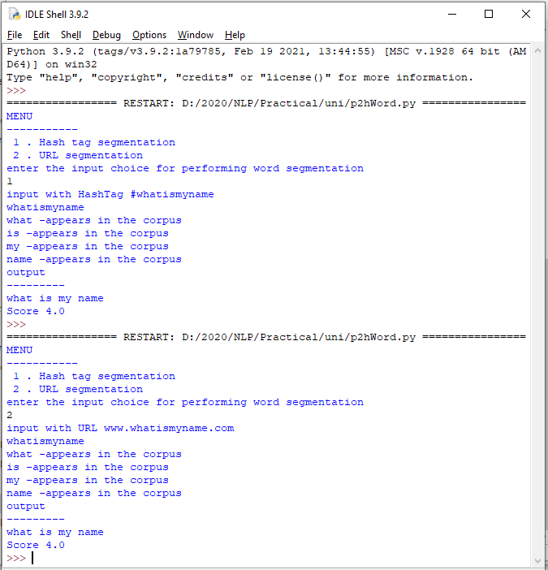

**PRACTICAL 3**

1. a. **Study of Wordnet Dictionary with methods as synsets, definitions, examples, antonyms**

# Source code:

'''WordNet provides synsets which is the collection of synonym words also called “lemmas”'''

import nltk

from nltk.corpus import wordnet print(wordnet.synsets("computer"))

# definition and example of the word ‘computer’ print(wordnet.synset("computer.n.01").definition())

#examples

print("Examples:", wordnet.synset("computer.n.01").examples())

#get Antonyms print(wordnet.lemma('buy.v.01.buy').antonyms())

# output:

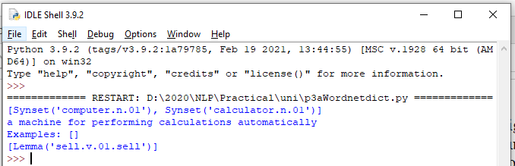

1. **Study lemmas, hyponyms, hypernyms. Source code:**

import nltk

from nltk.corpus import wordnet print(wordnet.synsets("computer")) print(wordnet.synset("computer.n.01").lemma_names()) #all lemmas for each synset.

for e in wordnet.synsets("computer"): print(f'{e} --> {e.lemma_names()}')

#print all lemmas for a given synset print(wordnet.synset('computer.n.01').lemmas())

#get the synset corresponding to lemma print(wordnet.lemma('computer.n.01.computing_device').synset())

#Get the name of the lemma print(wordnet.lemma('computer.n.01.computing_device').name())

#Hyponyms give abstract concepts of the word that are much more specific #the list of hyponyms words of the computer

syn = wordnet.synset('computer.n.01') print(syn.hyponyms)

print([lemma.name() for synset in syn.hyponyms() for lemma in synset.lemmas()]) #the semantic similarity in WordNet

vehicle = wordnet.synset('vehicle.n.01') car = wordnet.synset('car.n.01')

print(car.lowest_common_hypernyms(vehicle))

# Output:

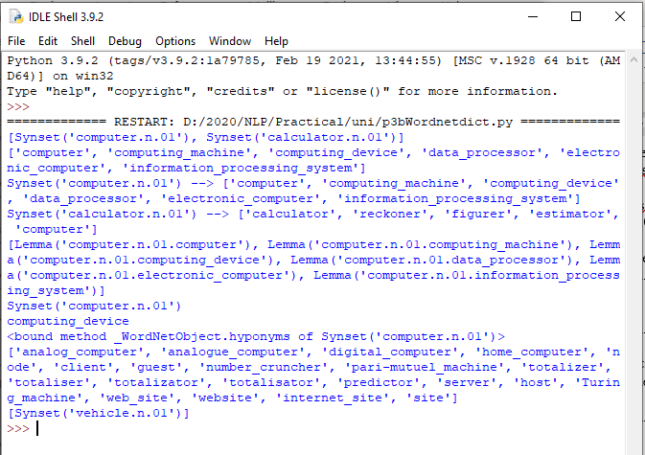

1. **Write a program using python to find synonym and antonym of word "active" using Wordnet.**

# Source code:

from nltk.corpus import wordnet print( wordnet.synsets("active"))

print(wordnet.lemma('active.a.01.active').antonyms())

Output:

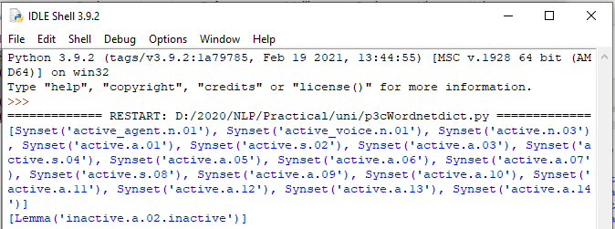

1. **Compare two nouns source code:**

import nltk

from nltk.corpus import wordnet

syn1 = wordnet.synsets('football') syn2 = wordnet.synsets('soccer')

# A word may have multiple synsets, so need to compare each synset of word1 with synset of word2

for s1 in syn1: for s2 in syn2:

print("Path similarity of: ")

print(s1, '(', s1.pos(), ')', '[', s1.definition(), ']')

print(s2, '(', s2.pos(), ')', '[', s2.definition(), ']') print(" is", s1.path_similarity(s2))

print()

# output:

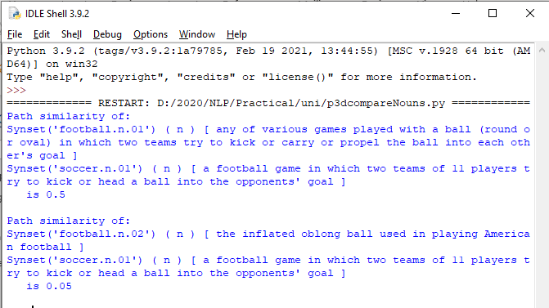

1. **Handling stopword:**

# Using nltk Adding or Removing Stop Words in NLTK's Default Stop Word List

**code:**

import nltk

from nltk.corpus import stopwords nltk.download('stopwords')

from nltk.tokenize import word_tokenize

text = "Yashesh likes to play football, however he is not too fond of tennis." text_tokens = word_tokenize(text)

tokens_without_sw = [word for word in text_tokens if not word in stopwords.words()]

print(tokens_without_sw)

#add the word play to the NLTK stop word collection all_stopwords = stopwords.words('english') all_stopwords.append('play')

text_tokens = word_tokenize(text)

tokens_without_sw = [word for word in text_tokens if not word in all_stopwords] print(tokens_without_sw)

#remove ‘not’ from stop word collection all_stopwords.remove('not')

text_tokens = word_tokenize(text)

tokens_without_sw = [word for word in text_tokens if not word in all_stopwords] print(tokens_without_sw)

# output

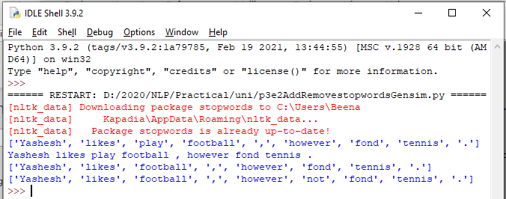

* 1. **Using Gensim Adding and Removing Stop Words in Default Gensim Stop Words List**

# code:

#pip install gensim import gensim

from gensim.parsing.preprocessing import remove_stopwords

text = "Yashesh likes to play football, however he is not too fond of tennis." filtered_sentence = remove_stopwords(text)

print(filtered_sentence)

all_stopwords = gensim.parsing.preprocessing.STOPWORDS print(all_stopwords)

'''The following script adds likes and play to the list of stop words in Gensim:''' from gensim.parsing.preprocessing import STOPWORDS all_stopwords_gensim = STOPWORDS.union(set(['likes', 'play']))

text = "Yashesh likes to play football, however he is not too fond of tennis." text_tokens = word_tokenize(text)

tokens_without_sw = [word for word in text_tokens if not word in all_stopwords_gensim]

print(tokens_without_sw) '''Output:

['Yashesh', 'football', ',', 'fond', 'tennis', '.']

The following script removes the word "not" from the set of stop words in Gensim:'''

from gensim.parsing.preprocessing import STOPWORDS all_stopwords_gensim = STOPWORDS

sw_list = {"not"}

all_stopwords_gensim = STOPWORDS.difference(sw_list)

text = "Yashesh likes to play football, however he is not too fond of tennis." text_tokens = word_tokenize(text)

tokens_without_sw = [word for word in text_tokens if not word in all_stopwords_gensim]

print(tokens_without_sw)

# output

Microsoft Visual C++ 14.0 is required. Get it with "Build Tools for Visual Studio": https://visualstudio.microsoft.com/downloads/

# Using Spacy Adding and Removing Stop Words in Default Spacy Stop Words List

**code:**

#pip install spacy

#python -m spacy download en_core_web_sm #python -m spacy download en

import spacy import nltk

from nltk.tokenize import word_tokenize sp = spacy.load('en_core_web_sm')

#add the word play to the NLTK stop word collection all_stopwords = sp.Defaults.stop_words all_stopwords.add("play")

text = "Yashesh likes to play football, however he is not too fond of tennis." text_tokens = word_tokenize(text)

tokens_without_sw = [word for word in text_tokens if not word in all_stopwords] print(tokens_without_sw)

#remove 'not' from stop word collection all_stopwords.remove('not')

tokens_without_sw = [word for word in text_tokens if not word in all_stopwords] print(tokens_without_sw)

# output:

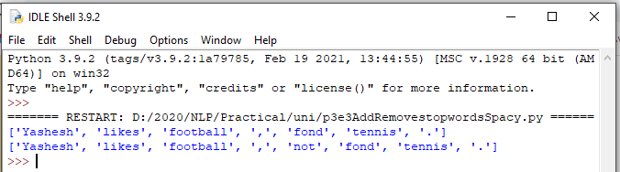

**PRACTICAL 4**

1. **Text Tokenization**

# Tokenization using Python’s split() function code:

text = """ This tool is an a beta stage. Alexa developers can use Get Metrics API to seamlessly analyse metric. It also supports custom skill model, prebuilt Flash Briefing model, and the Smart Home Skill API. You can use this tool for creation of monitors, alarms, and dashboards that spotlight changes. The release of these three tools will enable developers to create visual rich skills for Alexa devices with screens. Amazon describes these tools as the collection of tech and tools for creating visually rich and interactive voice experiences. """

data = text.split('.') for i in data:

print (i)

# output:

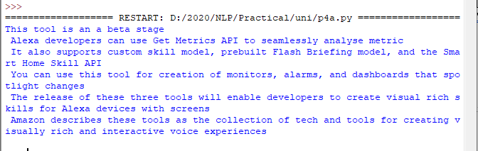

* 1. **Tokenization using Regular Expressions (RegEx) code:**

import nltk

# import RegexpTokenizer() method from nltk from nltk.tokenize import RegexpTokenizer

# Create a reference variable for Class RegexpTokenizer tk = RegexpTokenizer('\s+', gaps = True)

# Create a string input

str = "I love to study Natural Language Processing in Python"

# Use tokenize method tokens = tk.tokenize(str)

print(tokens)

# output:

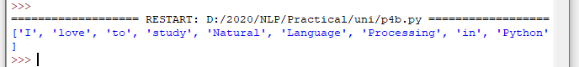

* 1. **Tokenization using NLTK**

# code:

import nltk

from nltk.tokenize import word_tokenize

# Create a string input

str = "I love to study Natural Language Processing in Python"

# Use tokenize method print(word_tokenize(str))

# output:



* 1. **Tokenization using the spaCy library code:**

import spacy

nlp = spacy.blank("en")

# Create a string input

str = "I love to study Natural Language Processing in Python"

# Create an instance of document;

# doc object is a container for a sequence of Token objects. doc = nlp(str)

# Read the words; Print the words #

words = [word.text for word in doc] print(words)

# output:

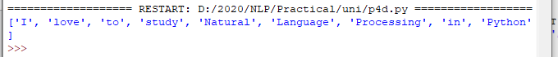

* 1. **Tokenization using Keras code:**

#pip install keras

#pip install tensorflow import keras

from keras.preprocessing.text import text_to_word_sequence # Create a string inputstr = "I love to study Natural Language Processing in Python"

# tokenizing the text

tokens = text_to_word_sequence(str) print(tokens)

# output:



* 1. **Tokenization using Gensim code:**

#pip install gensim

from gensim.utils import tokenize # Create a string input

str = "I love to study Natural Language Processing in Python"

# tokenizing the text list(tokenize(str))

# output:

Microsoft Visual C++ 14.0 is required. Get it with "Build Tools for Visual Studio": https://visualstudio.microsoft.com/downloads/

# PRACTICAL 5

# Import NLP Libraries for Indian Languages and perform:

Note: Execute this practical in <https://colab.research.google.com/>

# word tokenization in Hindi Source code:

!pip install torch==1.3.1+cpu -f https://download.pytorch.org/whl/torch_stable.html

!pip install inltk

!pip install tornado==4.5.3

from inltk.inltk import setup setup('hi')

from inltk.inltk import tokenize

hindi_text = """प्राकृ तिक भाषा सीखना बहुि तिलचस्प है।"""

# tokenize(input text, language code) tokenize(hindi_text, "hi")

# output

['▁प्राकृ तिक', '▁भाषा', '▁सीखना', '▁बहुि', '▁तिलचस्प', '▁है', '।']

# Generate similar sentences from a given Hindi text input Source code:

!pip install torch==1.3.1+cpu -f https://download.pytorch.org/whl/torch_stable.html

!pip install inltk

!pip install tornado==4.5.3

from inltk.inltk import setup setup('hi')

from inltk.inltk import get_similar_sentences

# get similar sentences to the one given in hindi

output = get_similar_sentences('मैं आज बहुि खुश हूं', 5, 'hi') print(output)

# Output:

['मैं आजकल बहुि खुश हूं', 'मैं आज अत्यतिक खुश हूं', 'मैं अभी बहुि खुश हूं', 'मैं वितमान बहुि खुश हूं', 'मैं वितमान बहुि खुश हूं']

# Identify the Indian language of a text Source code:

!pip install torch==1.3.1+cpu -f https://download.pytorch.org/whl/torch_stable.html

!pip install inltk

!pip install tornado==4.5.3

from inltk.inltk import setup setup('gu')

from inltk.inltk import identify_language #Identify the Lnaguage of given text identify_language('બીના કાપડિયા')

# Output:

gujarati

# PRACTICAL 6

# Illustrate part of speech tagging.

* 1. **Part of speech Tagging and chunking of user defined text.**

# Named Entity recognition of user defined text.

* 1. **Named Entity recognition with diagram using NLTK corpus – treebank**

# POS Tagging, chunking and NER:

1. **sentence tokenization, word tokenization, Part of speech Tagging and chunking of user defined text.**

# Source code:

import nltk

from nltk import tokenize nltk.download('punkt') from nltk import tag from nltk import chunk

nltk.download('averaged_perceptron_tagger') nltk.download('maxent_ne_chunker') nltk.download('words')

para = "Hello! My name is Beena Kapadia. Today you'll be learning NLTK." sents = tokenize.sent_tokenize(para)

print("\nsentence tokenization\n===================\n",sents)

# word tokenization

print("\nword tokenization\n===================\n") for index in range(len(sents)):

words = tokenize.word_tokenize(sents[index]) print(words)

# POS Tagging tagged_words = []

for index in range(len(sents)): tagged_words.append(tag.pos_tag(words))

print("\nPOS Tagging\n===========\n",tagged_words)

# chunking tree = []

for index in range(len(sents)): tree.append(chunk.ne_chunk(tagged_words[index])) print("\nchunking\n========\n")

print(tree)

# Output:

sentence tokenization

===================

['Hello!', 'My name is Beena Kapadia.', "Today you'll be learning NLTK."]

word tokenization

===================

['Hello', '!']

['My', 'name', 'is', 'Beena', 'Kapadia', '.']

['Today', 'you', "'ll", 'be', 'learning', 'NLTK', '.']

POS Tagging

===========

[[('Today', 'NN'), ('you', 'PRP'), ("'ll", 'MD'), ('be', 'VB'), ('learning', 'VBG'), ('NLTK',

'NNP'), ('.', '.')], [('Today', 'NN'), ('you', 'PRP'), ("'ll", 'MD'), ('be', 'VB'), ('learning',

'VBG'), ('NLTK', 'NNP'), ('.', '.')], [('Today', 'NN'), ('you', 'PRP'), ("'ll", 'MD'), ('be', 'VB'), ('learning', 'VBG'), ('NLTK', 'NNP'), ('.', '.')]]

chunking

========

[Tree('S', [('Today', 'NN'), ('you', 'PRP'), ("'ll", 'MD'), ('be', 'VB'), ('learning', 'VBG'),

Tree('ORGANIZATION', [('NLTK', 'NNP')]), ('.', '.')]), Tree('S', [('Today', 'NN'), ('you',

'PRP'), ("'ll", 'MD'), ('be', 'VB'), ('learning', 'VBG'), Tree('ORGANIZATION', [('NLTK', 'NNP')]), ('.', '.')]), Tree('S', [('Today', 'NN'), ('you', 'PRP'), ("'ll", 'MD'), ('be', 'VB'), ('learning', 'VBG'), Tree('ORGANIZATION', [('NLTK', 'NNP')]), ('.', '.')])]

# Named Entity recognition using user defined text. Source code:

!pip install -U spacy

!python -m spacy download en_core_web_sm import spacy

# Load English tokenizer, tagger, parser and NER nlp = spacy.load("en_core_web_sm")

# Process whole documents

text = ("When Sebastian Thrun started working on self-driving cars at " "Google in 2007, few people outside of the company took him " "seriously. “I can tell you very senior CEOs of major American "

"car companies would shake my hand and turn away because I wasn’t " "worth talking to,” said Thrun, in an interview with Recode earlier " "this week.")

doc = nlp(text)

# Analyse syntax

print("Noun phrases:", [chunk.text for chunk in doc.noun_chunks]) print("Verbs:", [token.lemma_ for token in doc if token.pos_ == "VERB"])

# Output:

Noun phrases: ['Sebastian Thrun', 'self-driving cars', 'Google', 'few people', 'the company', 'him', 'I', 'you', 'very senior CEOs', 'major American car companies', 'my hand', 'I', 'Thrun', 'an interview', 'Recode']

Verbs: ['start', 'work', 'drive', 'take', 'tell', 'shake', 'turn', 'be', 'talk', 'say']

# Named Entity recognition with diagram using NLTK corpus – treebank. Source code:

Note: It runs on Python IDLE

import nltk nltk.download('treebank')

from nltk.corpus import treebank_chunk treebank_chunk.tagged_sents()[0]

treebank_chunk.chunked_sents()[0] treebank_chunk.chunked_sents()[0].draw()

# Output:

**PRACTICAL 7**

**Finite state automata**

# Define grammar using nltk. Analyze a sentence using the same. Code:

import nltk

from nltk import tokenize

grammar1 = nltk.CFG.fromstring(""" S -> VP

VP -> VP NP NP -> Det NP

Det -> 'that'

NP -> singular Noun NP -> 'flight'

VP -> 'Book' """)

sentence = "Book that flight"

for index in range(len(sentence)):

all_tokens = tokenize.word_tokenize(sentence) print(all_tokens)

parser = nltk.ChartParser(grammar1) for tree in parser.parse(all_tokens):

print(tree) tree.draw()

output:

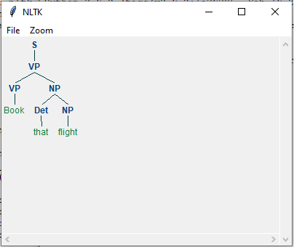

# Accept the input string with Regular expression of Finite Automaton: 101+. Source code:

def FA(s):

#if the length is less than 3 then it can't be accepted, Therefore end the process. if len(s)<3:

return "Rejected"

#first three characters are fixed. Therefore, checking them using index if s[0]=='1':

if s[1]=='0':

if s[2]=='1':

# After index 2 only "1" can appear. Therefore break the process if any other character is detected

for i in range(3,len(s)): if s[i]!='1':

return "Rejected"

return "Accepted" # if all 4 nested if true return "Rejected" # else of 3rd if

return "Rejected" # else of 2nd if return "Rejected" # else of 1st if

inputs=['1','10101','101','10111','01010','100','','10111101','1011111']

for i in inputs: print(FA(i))

# Output:

Rejected Rejected Accepted Accepted Rejected Rejected Rejected Rejected Accepted

# Accept the input string with Regular expression of FA: (a+b)*bba. Code:

def FA(s): size=0

#scan complete string and make sure that it contains only 'a' & 'b' for i in s:

if i=='a' or i=='b': size+=1

else:

return "Rejected"

#After checking that it contains only 'a' & 'b' #check it's length it should be 3 atleast

if size>=3:

#check the last 3 elements if s[size-3]=='b':

if s[size-2]=='b':

if s[size-1]=='a':

return "Accepted" # if all 4 if true return "Rejected" # else of 4th if

return "Rejected" # else of 3rd if return "Rejected" # else of 2nd if

return "Rejected" # else of 1st if

inputs=['bba', 'ababbba', 'abba','abb', 'baba','bbb',''] for i in inputs:

print(FA(i))

# output:

Rejected Rejected Accepted Accepted Rejected Rejected Rejected Rejected Accepted

# Implementation of Deductive Chart Parsing using context free grammar and a given sentence.

**Source code:**

import nltk

from nltk import tokenize

grammar1 = nltk.CFG.fromstring(""" S -> NP VP

PP -> P NP

NP -> Det N | Det N PP | 'I' VP -> V NP | VP PP

Det -> 'a' | 'my'

N -> 'bird' | 'balcony' V -> 'saw'

P -> 'in'

""")

sentence = "I saw a bird in my balcony"

for index in range(len(sentence)):

all_tokens = tokenize.word_tokenize(sentence) print(all_tokens)

# all_tokens = ['I', 'saw', 'a', 'bird', 'in', 'my', 'balcony'] parser = nltk.ChartParser(grammar1)

for tree in parser.parse(all_tokens): print(tree)

tree.draw()

# output:

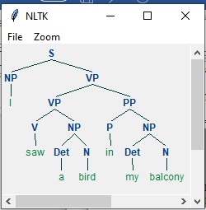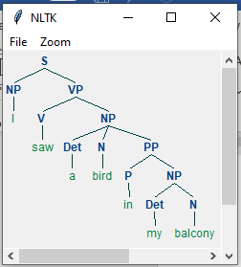

**PRACTICAL 8**

1. **Study PorterStemmer, LancasterStemmer, RegexpStemmer, SnowballStemmer Study WordNetLemmatizer**

# Code:

# **PorterStemmer**

import nltk

from nltk.stem import PorterStemmer word_stemmer = PorterStemmer() print(word_stemmer.stem('writing')) **Output:**



# #LancasterStemmer

import nltk

from nltk.stem import LancasterStemmer Lanc_stemmer = LancasterStemmer() print(Lanc_stemmer.stem('writing')) **Output:**



# #RegexpStemmer

import nltk

from nltk.stem import RegexpStemmer

Reg_stemmer = RegexpStemmer('ing$|s$|e$|able$', min=4) print(Reg_stemmer.stem('writing'))

# output



**#SnowballStemmer**

import nltk

from nltk.stem import SnowballStemmer english_stemmer = SnowballStemmer('english') print(english_stemmer.stem ('writing'))

# output



**#WordNetLemmatizer**

from nltk.stem import WordNetLemmatizer lemmatizer = WordNetLemmatizer()

print("word :\tlemma")

print("rocks :", lemmatizer.lemmatize("rocks")) print("corpora :", lemmatizer.lemmatize("corpora"))

# a denotes adjective in "pos"

print("better :", lemmatizer.lemmatize("better", pos ="a"))

**Output:**

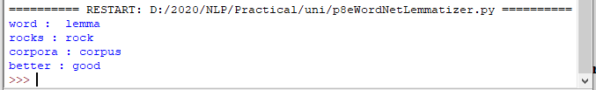

# PRACTICAL 9

# Implement Naive Bayes classifier

# Code:

#pip install pandas #pip install sklearn

import pandas as pd import numpy as np

sms_data = pd.read_csv("spam.csv", encoding='latin-1') import re

import nltk

from nltk.corpus import stopwords

from nltk.stem.porter import PorterStemmer

stemming = PorterStemmer() corpus = []

for i in range (0,len(sms_data)):

s1 = re.sub('[^a-zA-Z]',repl = ' ',string = sms_data['v2'][i]) s1.lower()

s1 = s1.split()

s1 = [stemming.stem(word) for word in s1 if word not in set(stopwords.words('english'))]

s1 = ' '.join(s1) corpus.append(s1)

from sklearn.feature_extraction.text import CountVectorizer countvectorizer =CountVectorizer()

x = countvectorizer.fit_transform(corpus).toarray() print(x)

y = sms_data['v1'].values print(y)

from sklearn.model_selection import train_test_split x_train,x_test,y_train,y_test = train_test_split(x,y,test_size = 0.3, stratify=y,random_state=2)

#Multinomial Naïve Bayes.

from sklearn.naive_bayes import MultinomialNB multinomialnb = MultinomialNB() multinomialnb.fit(x_train,y_train)

# Predicting on test data:

y_pred = multinomialnb.predict(x_test) print(y_pred)

#Results of our Models

from sklearn.metrics import classification_report, confusion_matrix from sklearn.metrics import accuracy_score

print(classification_report(y_test,y_pred)) print("accuracy_score: ",accuracy_score(y_test,y_pred))

# input:

spam.csv file from github

# output:

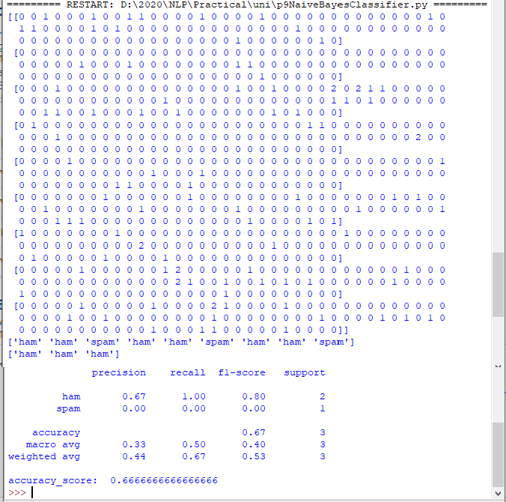

**PRACTCIAL 10**

1. **a. Speech Tagging:**

# Speech tagging using spacy

**code**

import spacy

sp = spacy.load('en_core_web_sm')

sen = sp(u"I like to play football. I hated it in my childhood though") print(sen.text)

print(sen[7].pos_) print(sen[7].tag_) print(spacy.explain(sen[7].tag_)) for word in sen:

print(f'{word.text:{12}} {word.pos_:{10}} {word.tag_:{8}}

{spacy.explain(word.tag_)}')

sen = sp(u'Can you google it?') word = sen[2]

print(f'{word.text:{12}} {word.pos_:{10}} {word.tag_:{8}}

{spacy.explain(word.tag_)}')

sen = sp(u'Can you search it on google?') word = sen[5]

print(f'{word.text:{12}} {word.pos_:{10}} {word.tag_:{8}}

{spacy.explain(word.tag_)}')

#Finding the Number of POS Tags

sen = sp(u"I like to play football. I hated it in my childhood though")

num_pos = sen.count_by(spacy.attrs.POS) num_pos

for k,v in sorted(num_pos.items()): print(f'{k}. {sen.vocab[k].text:{8}}: {v}')

#Visualizing Parts of Speech Tags from spacy import displacy

sen = sp(u"I like to play football. I hated it in my childhood though") displacy.serve(sen, style='dep', options={'distance': 120})

# output:

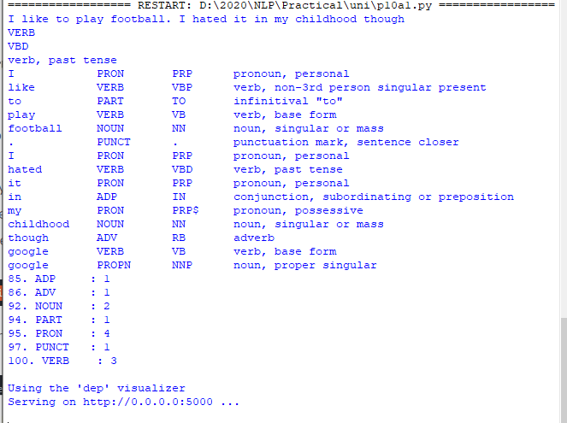

To view the dependency tree, type the following address in your browser: http://127.0.0.1:5000/. You will see the following dependency tree:

# Speech tagging using nktl code:

import nltk

from nltk.corpus import state_union

from nltk.tokenize import PunktSentenceTokenizer

#create our training and testing data:

train_text = state_union.raw("2005-GWBush.txt") sample_text = state_union.raw("2006-GWBush.txt")

#train the Punkt tokenizer like:

custom_sent_tokenizer = PunktSentenceTokenizer(train_text)

# tokenize:

tokenized = custom_sent_tokenizer.tokenize(sample_text)

def process_content(): try:

for i in tokenized[:2]:

words = nltk.word_tokenize(i) tagged = nltk.pos_tag(words)

print(tagged)

except Exception as e: print(str(e))

process_content()

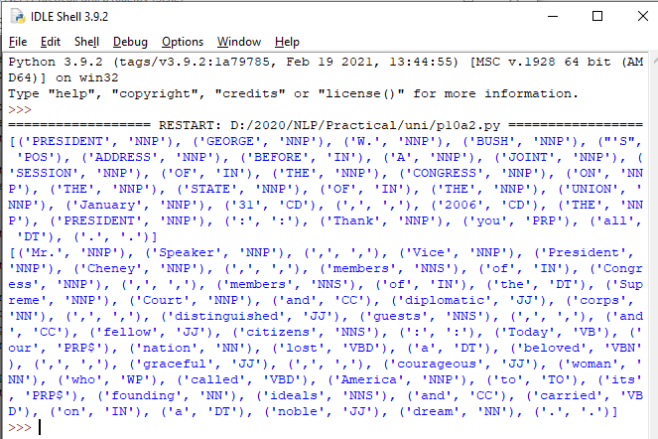**output:**

# b. Statistical parsing:

1. **Usage of Give and Gave in the Penn Treebank sample Source code:**

#probabilitistic parser

#Usage of Give and Gave in the Penn Treebank sample

import nltk

import nltk.parse.viterbi import nltk.parse.pchart

def give(t):

return t.label() == 'VP' and len(t) > 2 and t[1].label() == 'NP'\ and (t[2].label() == 'PP-DTV' or t[2].label() == 'NP')\

and ('give' in t[0].leaves() or 'gave' in t[0].leaves())

def sent(t):

return ' '.join(token for token in t.leaves() if token[0] not in '*-0')

def print_node(t, width):

output = "%s %s: %s / %s: %s" %\

(sent(t[0]), t[1].label(), sent(t[1]), t[2].label(), sent(t[2])) if len(output) > width:

output = output[:width] + "..." print (output)

for tree in nltk.corpus.treebank.parsed_sents(): for t in tree.subtrees(give):

print_node(t, 72)

# Output:

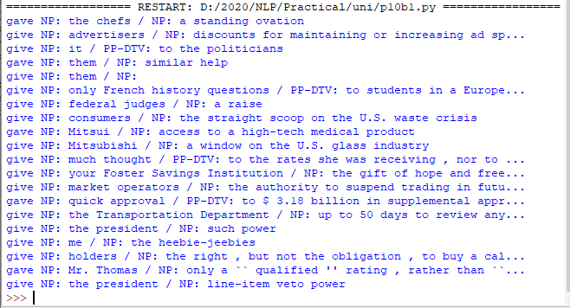

1. **probabilistic parser Source code:**

import nltk

from nltk import PCFG

grammar = PCFG.fromstring('''

NP -> NNS [0.5] | JJ NNS [0.3] | NP CC NP [0.2]

NNS -> "men" [0.1] | "women" [0.2] | "children" [0.3] | NNS CC NNS [0.4] JJ -> "old" [0.4] | "young" [0.6]

CC -> "and" [0.9] | "or" [0.1] ''')

print(grammar)

viterbi_parser = nltk.ViterbiParser(grammar) token = "old men and women".split()

obj = viterbi_parser.parse(token)

print("Output: ") for x in obj:

print(x)

# Output:

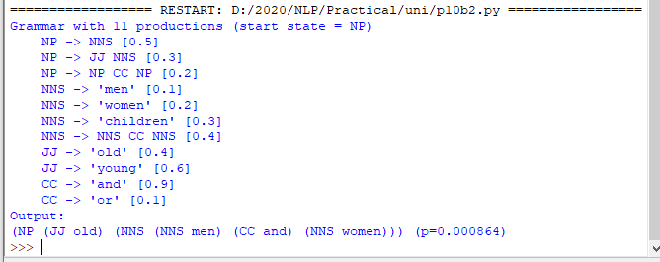

**c. Malt parsing:**

# Parse a sentence and draw a tree using malt parsing.

Note: 1) Java should be installed.

1. maltparser-1.7.2 zip file should be copied in C:\Users\Beena Kapadia\AppData\Local\Programs\Python\Python39 folder and should be extracted in the same folder.
2. engmalt.linear-1.7.mco file should be copied to C:\Users\Beena Kapadia\AppData\Local\Programs\Python\Python39 folder **Source code:**

# copy maltparser-1.7.2(unzipped version) and engmalt.linear-1.7.mco files to C:\Users\Beena Kapadia\AppData\Local\Programs\Python\Python39 folder

# java should be installed

# environment variables should be set - MALT_PARSER - C:\Users\Beena Kapadia\AppData\Local\Programs\Python\Python39\maltparser-1.7.2 and MALT_MODEL - C:\Users\Beena Kapadia\AppData\Local\Programs\Python\Python39\engmalt.linear-1.7.mco

from nltk.parse import malt

mp = malt.MaltParser('maltparser-1.7.2', 'engmalt.linear-1.7.mco')#file t = mp.parse_one('I saw a bird from my window.'.split()).tree()

print(t) t.draw()

# Output:

(saw I (bird a (from (window. my))))

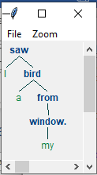

# PRACTICAL 11

# a) Multiword Expressions in NLP Source code:

# Multiword Expressions in NLP

from nltk.tokenize import MWETokenizer from nltk import sent_tokenize, word_tokenize

s = '''Good cake cost Rs.1500\kg in Mumbai. Please buy me one of them.\n\nThanks.''' mwe = MWETokenizer([('New', 'York'), ('Hong', 'Kong')], separator='_')

for sent in sent_tokenize(s): print(mwe.tokenize(word_tokenize(sent)))

# Output:

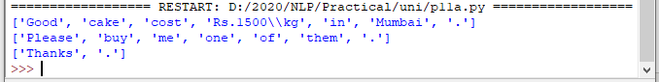

1. **Normalized Web Distance and Word Similarity Source code:**

# Normalized Web Distance and Word Similarity #convert

#Reliance supermarket #Reliance hypermarket #Reliance

#Reliance

#Reliance downtown #Relianc market #Mumbai

#Mumbai Hyper #Mumbai dxb #mumbai airport #k.m trading #KM Trading #KM trade #K.M. Trading #KM.Trading

#into

#Reliance #Reliance #Reliance #Reliance #Reliance #Reliance #Mumbai #Mumbai #Mumbai #Mumbai

#KM Trading #KM Trading #KM Trading #KM Trading #KM Trading

import numpy as np import re

import textdistance # pip install textdistance # we will need scikit-learn>=0.21

import sklearn #pip install sklearn

from sklearn.cluster import AgglomerativeClustering

texts = [

'Reliance supermarket', 'Reliance hypermarket', 'Reliance', 'Reliance', 'Reliance downtown', 'Relianc market',

'Mumbai', 'Mumbai Hyper', 'Mumbai dxb', 'mumbai airport',

'k.m trading', 'KM Trading', 'KM trade', 'K.M. Trading', 'KM.Trading'

]

def normalize(text):

""" Keep only lower-cased text and numbers""" return re.sub('[^a-z0-9]+', ' ', text.lower())

def group_texts(texts, threshold=0.4):

""" Replace each text with the representative of its cluster""" normalized_texts = np.array([normalize(text) for text in texts]) distances = 1 - np.array([

[textdistance.jaro_winkler(one, another) for one in normalized_texts] for another in normalized_texts

])

clustering = AgglomerativeClustering(

distance_threshold=threshold, # this parameter needs to be tuned carefully affinity="precomputed", linkage="complete", n_clusters=None

).fit(distances) centers = dict()

for cluster_id in set(clustering.labels_):

index = clustering.labels_ == cluster_id

centrality = distances[:, index][index].sum(axis=1) centers[cluster_id] = normalized_texts[index][centrality.argmin()] return [centers[i] for i in clustering.labels_]

print(group_texts(texts))

# Output:

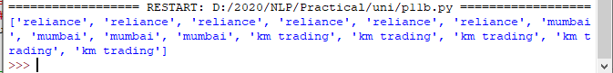

1. **Word Sense Disambiguation Source code:**

#Word Sense Disambiguation

from nltk.corpus import wordnet as wn

def get_first_sense(word, pos=None): if pos:

synsets = wn.synsets(word,pos) else:

synsets = wn.synsets(word) return synsets[0]

best_synset = get_first_sense('bank')

print ('%s: %s' % (best_synset.name, best_synset.definition)) best_synset = get_first_sense('set','n')

print ('%s: %s' % (best_synset.name, best_synset.definition)) best_synset = get_first_sense('set','v')

print ('%s: %s' % (best_synset.name, best_synset.definition))

# Output:

